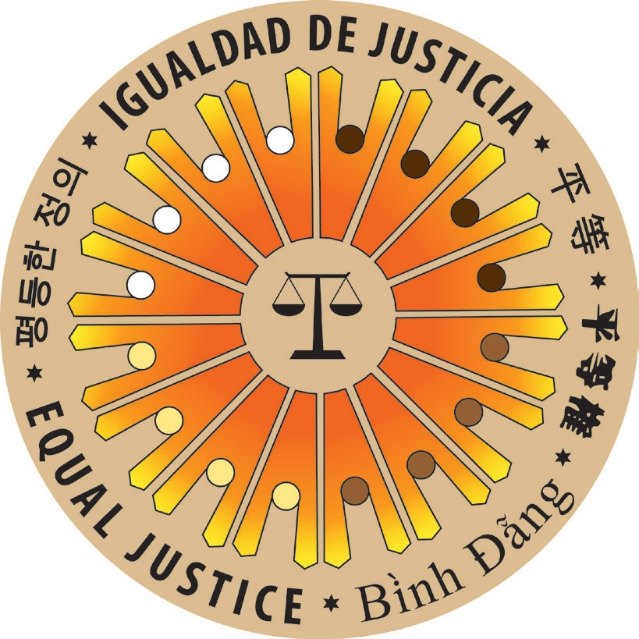NATIONAL CONSORTIUM ON RACIAL
AND ETHNIC FAIRNESS IN THE COURTS

26th Annual Meeting

June 25–28, 2014
Cody & Heart Mountain, Wyoming

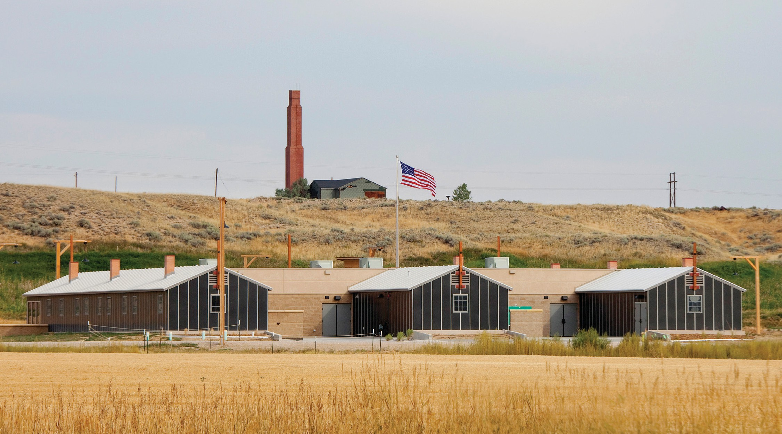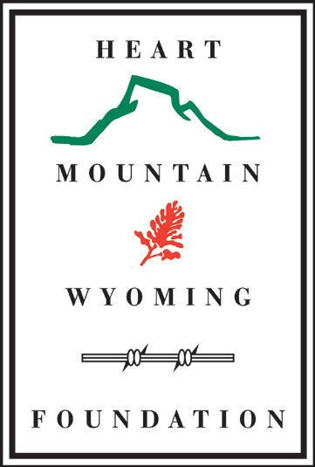Hosted by the Heart Mountain Wyoming Foundation
1539 Road 19
Powell, WY 82435

heartmountain.org info@heartmountain.org

Registration Form
If you have any questions, please call us at: (307) 754-­‐8000

To mail in your form and payment, please send to:
The Heart Mountain Wyoming Foundation
1539 Road 19 Powell, WY 82435
To submit via email, send to:
sbroussard-­‐ext@heartmountain.org
To make your reservation via phone, call:
(307) 754-­‐8000

Prefix: First: MI: Last:

Badge Name (if different from above):

Court/Company:

Email: Zip Code:

Work Phone: Cell phone:

Special Needs:

Dietary Restrictions:  Vegetarian  Other (please specify):

Registration: Registration includes admission to the entire conference, i.e., educational sessions, receptions, and meals. Lawyers are eligible for CLE credit. Not included in the registration fee is the trip to Yellowstone National Park.
 $425.00 Early Bird (before March 17, 2014)  $475.00 Regular (after March 17, 2014)

 $80.00 Yellowstone Tour on Saturday, June 28, 7:30 a.m. – 6:00 p.m., with a box lunch and roundtrip bus ride

Guests: Guests may register for events. Please provide guest names and list initials for each event they will attend.

1) |  | 2)
3) |  | 4)
Welcome Reception ($65.00) |  | Interpretive Center Tour & Seminar ($25.00)
Thursday Keynote Address ($25.00) |  | Draft Resister Trial Reenactment ($12.00)
Friday Keynote Address ($25.00) |  | Closing Reception ($75.00)
Thursday Box Lunch ($12.00) |  | Yellowstone Tour ($80.00)
Friday Box Lunch ($12.00)
Payment Method:  Check |  |  Cash  Credit/Debit
Make payable to “HMWF – Consortium”. Fill in additional information below.

Card number: CCV #: Expiration Date: / /

Name as it appears on Card:

Signature of Cardholder:

Attendees may type their signatures should they wish to complete the form electronically.

Cancellation policy: Cancellations received by 5:00 p.m. MT on June 1, 2014 will be refunded, minus a $100 processing
fee. Cancellations received after that date will be refunded minus a $200 processing fee. Cancellation of registration must
be made in writing and emailed to sbroussard-­‐ext@heartmountain.org.

Welcome to Cody, Wyoming!

The Heart Mountain Wyoming Foundation and the National Consortium on Racial and Ethnic Fairness in the Courts are pleased to present the 26th Annual Meeting of the National Consortium on Racial and Ethnic Fairness in the Courts. The Heart Mountain Interpretive Center is located on the site where 14,000 people of Japanese ancestry, two-­‐thirds of whom were American citizens, were wrongly incarcerated during World War II. The area is a compelling venue for this conference, which seeks to examine the treatment of minorities in the courts.

Tourism

Founded by Buffalo Bill, Cody is a town that has an abundance of beautiful sights and fun activities. At Yellowstone National Park’s East Entrance, just 52 miles from Cody, you can see the rugged and wondrous Rocky Mountain West at its best. Observe big horn sheep, bison, eagles, antelope, and more in their natural habitats on a tour of the area. Float down the Shoshone River with one of Cody’s white water rafting companies.

Cheer on the cowboys and cowgirls at the Cody Nite Rodeo. Watch the Cody Gun Fight Reenactment outside of the historic Irma Hotel. Listen to some cowboy music at Dan Miller’s Cowboy Revue or enjoy a chuck wagon buffet and musical entertainment with the Cody Cattle Company. Shops offer local crafts and gear—maybe it’s time to invest in a pair of authentic cowboy (and cowgirl) boots.

Flights

Attendees have two airport options: Yellowstone Regional Airport, which is a 5-­‐minute drive from the Holiday Inn; and the Billings Logan International Airport, which is a 2-­‐hour drive from Cody (110 miles of beautiful scenery). The key to getting good rates for flights into Cody is to book early. Delta and United Airlines service Cody’s Yellowstone Regional Airport. When booking your flight, please avoid tight connections, as it can be difficult to find another flight into Cody on the same day if you miss a connecting flight.

Car Rentals

The Heart Mountain Wyoming Foundation will be providing bus service between the various lodging options, the Interpretive Center, and other conference events. Should you wish to rent a car for more flexibility, you have a variety of local options:

Budget Rent A Car
Phone: (800)-­‐527-­‐7000 or (307)-­‐587-­‐6066
Website: www.budgetrentacar.com Hertz Car Rental
Phone: (800)-­‐654-­‐3131 or (307)-­‐587-­‐2914
Website: www.hertz.com

Taxi & Shuttle Services
Thrifty Car Rental
Phone: (800)-­‐THRIFTY or (307)-­‐587-­‐8855
Website: www.thrifty.com

Marquis Sedan Service and Cody Shuttle Service provide service from the Billings Airport to Cody. You must book shuttles in advance. Some hotels may offer a shuttle to and from the Cody airport. If not, there are taxi services available:

Cody Shuttle Service
Phone: (307)-­‐527-­‐6789
Marquis Sedan Service
Phone: (307)-­‐254-­‐2357
Cody Cab
Phone: (307)-­‐272-­‐8364

Lodging

The following lodging venues are providing discounted rates for the 26th Annual Meeting of the National Consortium on Racial and Ethnic Fairness in the Courts. The plenary breakfasts and breakout sessions will be held at the Holiday Inn. Mention the discount code “NCREFC,” when booking.

Hotel | Phone Number | Price (does not include 8% tax)
Holiday Inn | (307)-­‐587-­‐5555 | Room: $144.00
Buffalo Bill Village Cabins | (307)-­‐587-­‐5544 | One Bed: $109.00
 |  | Two Beds: $144.00
Cody Cowboy Village | (307)-­‐587-­‐7555 | King Bed: $155.00  Double Queen Beds: $165.00
Big Bear Motel | (307)-­‐587-­‐3117 | Room: $69.00
Best Western Sunset Motor Inn | (307)-­‐587-­‐4265 | Double Queen Beds: $139.50  King Bed: $139.50

Current Program (Subject to Revision)

Wednesday, June 25, 2014
6:00 p.m. – 9:00 p.m. Opening Reception
Buffalo Bill Center of the West

Thursday, June 26, 2014
8:30 a.m. – 10:00 a.m. Keynote Address
Holiday Inn
Secretary Norman Y. Mineta
Former Secretary of Commerce and Transportation
Senator Alan K. Simpson
U.S. Senator from 1979 to 1997
10:15 a.m. – 12:00 p.m. Breakout Sessions
Holiday Inn
Beyond Padilla v. Kentucky: Non-­‐Citizens in the Criminal Justice System
Gabriel “Jack” Chin, J.D., LL.M.
Professor of Law, University of California, Davis, School of Law
Tribal Courts: History, Current Issues, and the Relationship with State Courts
The Honorable John St. Clair
Chief Judge, Shoshone & Arapaho Tribal Court
The Honorable Winona Tanner
Chief Judge, Confederated Salish & Kootenia Tribal Court
The Honorable B.J. Jones
Chief Justice, Turtle Mountain Tribal Court of Appeals
Director, Tribal Judicial Institute at the University of North Dakota School of Law

Heart Mountain Interpretive Center
Museum Tour and Seminar: Legal Perspectives on the Heart Mountain Story
Eric Muller, J.D.
Dan K. Moore Distinguished Professor of Law in Jurisprudence and Ethics, University of North Carolina
School of Law
Director, Center for Faculty Excellence, University of North Carolina at Chapel Hill
12:30 p.m. – 3:15 p.m. Training Workshop on Implicit Bias in the Courtroom
Holiday Inn
Kimberly Papillon, J.D.
Attorney and Special Education Specialist, Education Division of the California Judicial Council’s
Administrative Office of the Courts
1:00 p.m. – 2:30 p.m.
Heart Mountain Interpretive Center
Museum Tour and Seminar: Legal Perspectives on the Heart Mountain Story (Repeat Session)
3:45 p.m. – 5:15 p.m. Breakout Sessions
Holiday Inn
Language Access in the Courts
Hiroshi Motomura, J.D.
Susan Westerberg Prager Professor of Law, University of California, Los Angeles, School of Law
Youth Involvement in the Criminal Justice System: The Way In and the Way Out
Robert L. Listenbee, Jr., J.D.
Administrator of the Office of Juvenile Justice and Delinquency Prevention, U.S. Department of Justice
Erica Nelson, J.D.
Project Director, Race to Equity Project of the Wisconsin Council on Children and Families
(Additional speakers to be confirmed)
3:45 p.m. – 5:15 p.m.
Heart Mountain Interpretive Center
Museum Tour and Seminar: Legal Perspectives on the Heart Mountain Story (Repeat Session)
7:30 p.m. – 9:00 p.m. Heart Mountain Draft Resister Trial Reenactment and Panel Discussion
Cody Auditorium
“Heart Mountain: Conscience, Loyalty, and the Constitution”
The Honorable Denny Chin
Judge, U.S. Court of Appeals for the Second Circuit
Kathy Hirata-­‐Chin
Partner, Cadwalader, Wickersham and Taft LLP
(Full cast TBA)

Friday, June 27, 2014
8:30 a.m. – 10:00 a.m. Keynote Address
Holiday Inn
The Honorable Lance Ito
Judge, L.A. Superior Court

10:15 a.m. – 11:45 a.m. Breakout Sessions
Holiday Inn
Immigration Status and Collateral Consequences in Divorce, Child Protective, and Delinquency
Proceedings
David B. Thronson, J.D.
Associate Dean for Academic Affairs and Professor of Law, Michigan State University College of Law
Giselle Hass, Psy.D.
Contract Psychologist, D.C. Commission on Mental Health Services’ Youth Forensics Services Division
Challenges for Low-­‐Income Populations
Diane E. Courselle, J.D.
Director, Defender Aid Program
Winston S. Howard Distinguished Professor of Law, University of Wyoming College of Law
(Additional speakers to be confirmed)
10:30 a.m. – 12:00 p.m.
Heart Mountain Interpretive Center
Museum Tour and Seminar: Legal Perspectives on the Heart Mountain Story (Repeat Session)
12:30 – 1:00 p.m. General Business Meeting
Holiday Inn
12:30 p.m. – 2:00 p.m.
Heart Mountain Interpretive Center
Museum Tour and Seminar: Legal Perspectives on the Heart Mountain Story (Repeat Session)
1:15 p.m. – 2:45 p.m. Breakout Session
Holiday Inn
Immigrant Rights in the Courts
Hiroshi Motomura, J.D.
Susan Westerberg Prager Professor of Law, University of California, Los Angeles, School of Law
Gabriel “Jack” Chin, J.D, LL.M.
Professor of Law, University of California, Davis, School of Law
David B. Thronson, J.D.
Associate Dean for Academic Affairs and Professor of Law, Michigan State University College of Law
Melba Vasquez, Ph.D.
Past President (2011), American Psychological Association
Heart Mountain Interpretive Center
Museum Tour and Seminar: Legal Perspectives on the Heart Mountain Story (Repeat Session)
3:00 p.m. – 4:45 p.m. Annual Report of the States
Holiday Inn
The Honorable Edward C. Clifton
Judge, Superior Court of Rhode Island
6:15 p.m. – 8:30 p.m. Closing Reception
Heart Mountain Interpretive Center

